

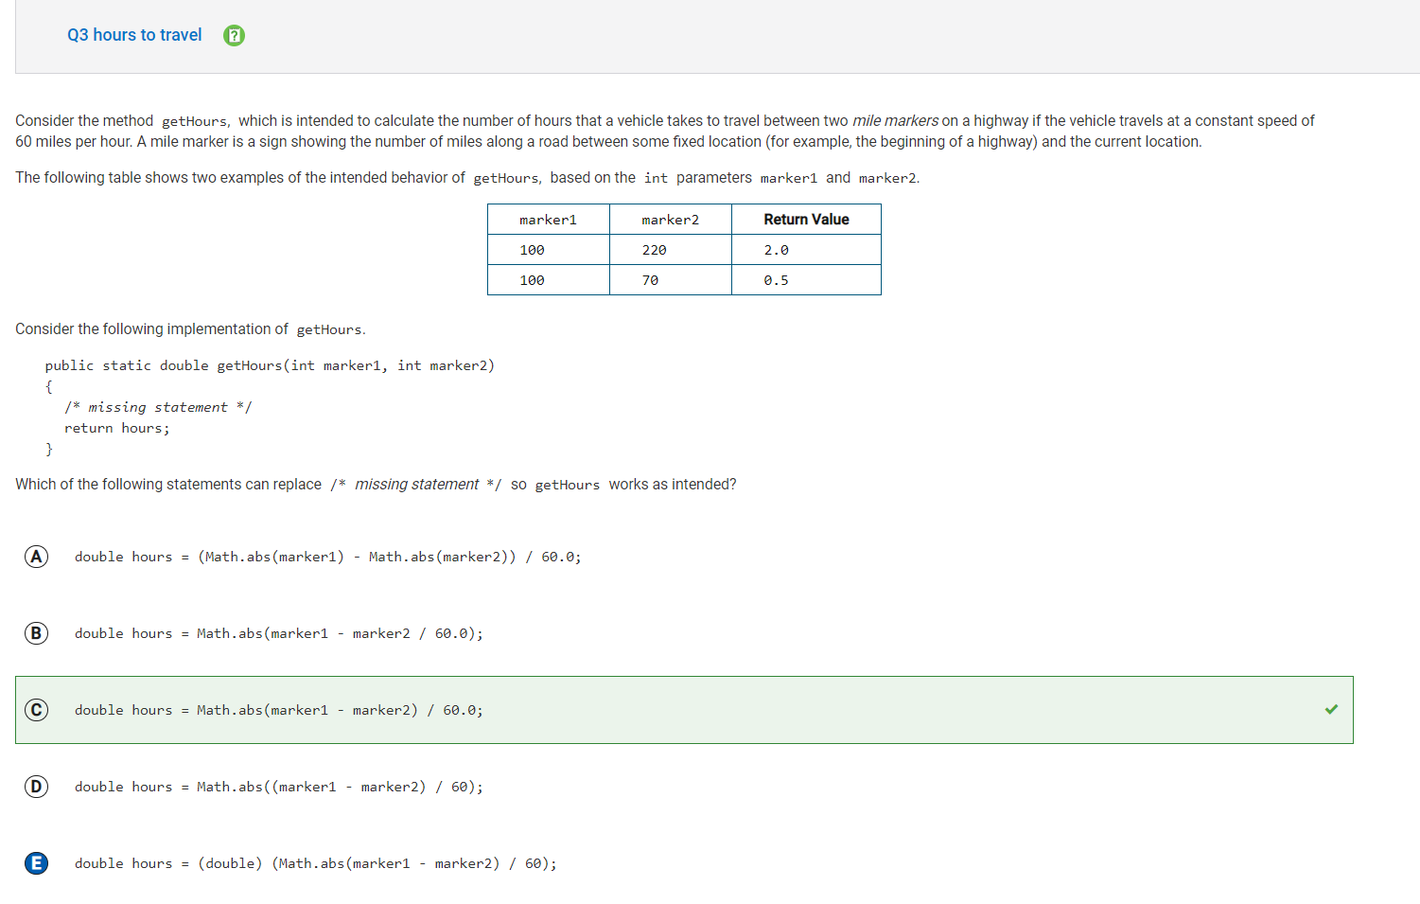

In this case E would be wrong because dividing and integer value and a double value will automatically output a double, so there is not need to turn it into a double. C would be right because there is no need to turn the value into a double if it already is one.

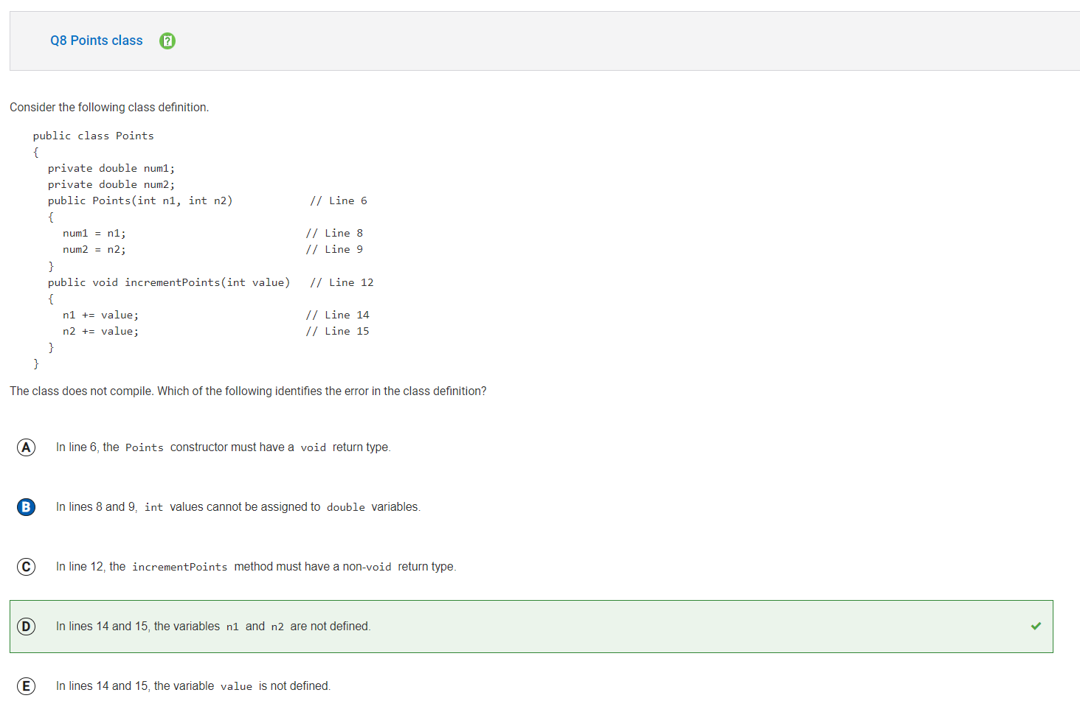

B is incorrect because you can assign int values to double values. D is correct because they are not instance variables of the Points class and they are not defined anywhere in the incrementPoints method.

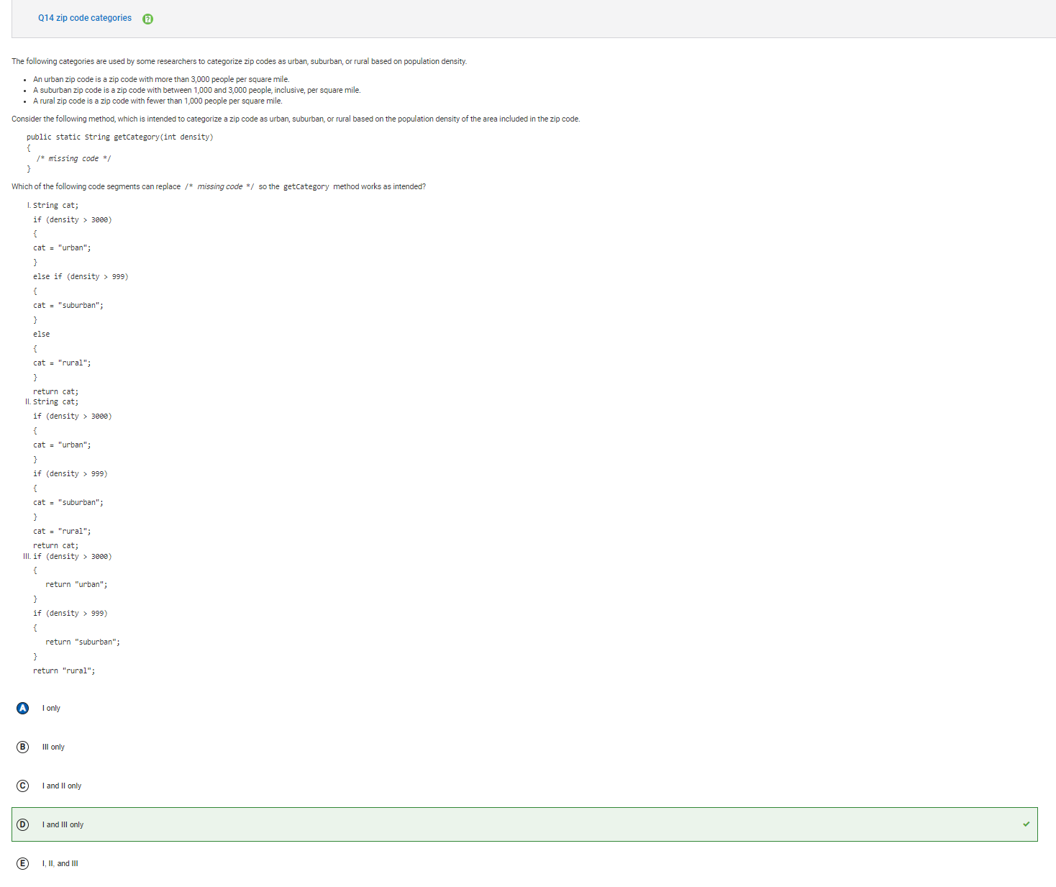

A is incorrect because in the III code segment would also return the correct category because the logic is correct.

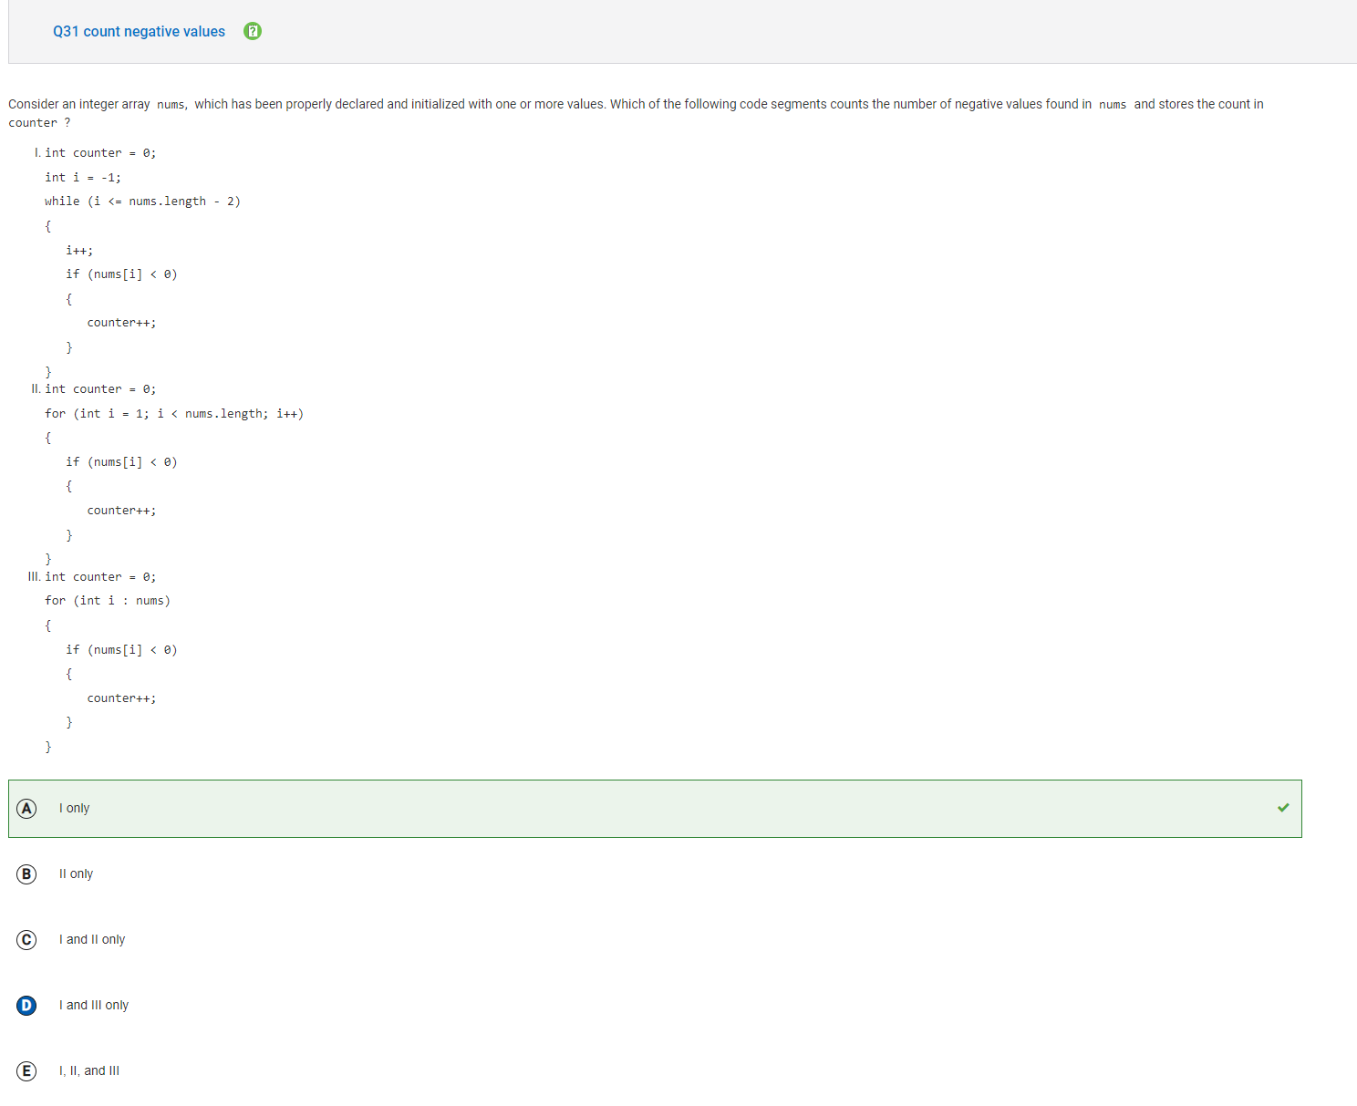

D is incorrect because in the III code segment i is representing the element not the index of the array. So I is the only correct answer.